The Evolution of Artificial Intelligence:

From Science Fiction to Societal Infrastructure

April V. Sykes
Olympic College
IS390
Richard Becker
June 7, 2025

Abstract
Artificial intelligence has evolved from a theoretical idea rooted in science fiction into a real-world system shaping how we live, work, and think. This paper explores the development of AI, starting from early logic-based machines to the rise of modern neural networks and generative systems. It traces key breakthroughs like Deep Blue, AlphaGo, and the transformer model, while also addressing the ethical, environmental, and legal consequences of rapid deployment. With examples from health care, defense, and everyday tools like ChatGPT, this report shows that AI is no longer just a technology. It has become part of the infrastructure that supports modern life. The discussion highlights regulatory gaps, privacy risks, intellectual property conflicts, and the urgent need for policies that keep up with innovation. As AI continues to advance, society must choose how to shape it and how to live with it.

The Evolution of Artificial Intelligence:

From Science Fiction to Societal Infrastructure

Artificial intelligence has moved from fiction to fact, from Turing’s early ideas to the infrastructure that now supports everyday life. The term is still widely misunderstood. Public opinion and even business leaders often confuse it with sentient robots or science fiction systems like HAL or Skynet, ignoring the actual systems already shaping how we work, learn, and communicate (Suleyman, 2023).
The field was formally launched in 1956 during the Dartmouth Conference. Before that, Alan Turing reframed the question “Can machines think?” into “Can a machine be linguistically indistinguishable from a human?” and proposed the Turing Test to measure this ​(Moor, 2020)

From that point on researchers have debated what counts as intelligence and what autonomy means in both hardware and software.
Figure 1. Alan Turing, pioneer of artificial intelligence.
Source: Image licensed from Adobe Stock (Asset ID: 1383987287).
Early milestones showed what narrow AI could do. In 1997 IBM’s Deep Blue defeated chess champion Garry Kasparov. Then in 2016 AlphaGo defeated Go world champion Lee Sedol. These early AI systems could handle complex games but couldn’t explain their moves, apply what they learned elsewhere, or understand natural language ​(Moor, 2020). Suleyman (2023) describes this as narrow intelligence and warns that while such systems are limited, their scale and speed of deployment create new risks.
Today AI is embedded in tools used for healthcare, finance, education, and military applications. Its full consequences are still unknown. Suleyman (2023) argues these systems are not just tools. They are capability platforms that can evolve quickly and cause harm if left unregulated. The need to define, contain, and manage AI is immediate, not hypothetical. This paper looks at one main question: How did artificial intelligence go from science fiction to something shaping everyday life? AI has moved fast from a big idea to real infrastructure. That speed brings serious challenges with regulation, control, and ethics. Society is being forced to keep up with technology, changing faster than we can manage.
Artificial intelligence began in 1956 at the Dartmouth Summer Research Project. John McCarthy, Marvin Minsky, Claude Shannon, and others believed machines could be built to copy parts of human thinking. That event kicked off AI as its own field of study ​(Moor, 2020)
In 1950, Alan Turing took a different approach. He didn’t ask if machines could think. He asked if a machine could answer questions in a way that made it impossible to tell if it was human. That became the Turing Test, and it’s still one of the core ideas in AI today ​(Moor, 2020)
The intellectual roots of AI stretch further back. Philosophers like Descartes and Pascal laid the foundation by developing formal ideas about logic, reasoning, and probability. These concepts were later used to shape the early structure of computer science itself. Scholars like Glymour and Halpern have shown how first-order logic and conditional probability became central to how AI systems are built and understood (Glymour, 1992; Halpern et al., 2001).
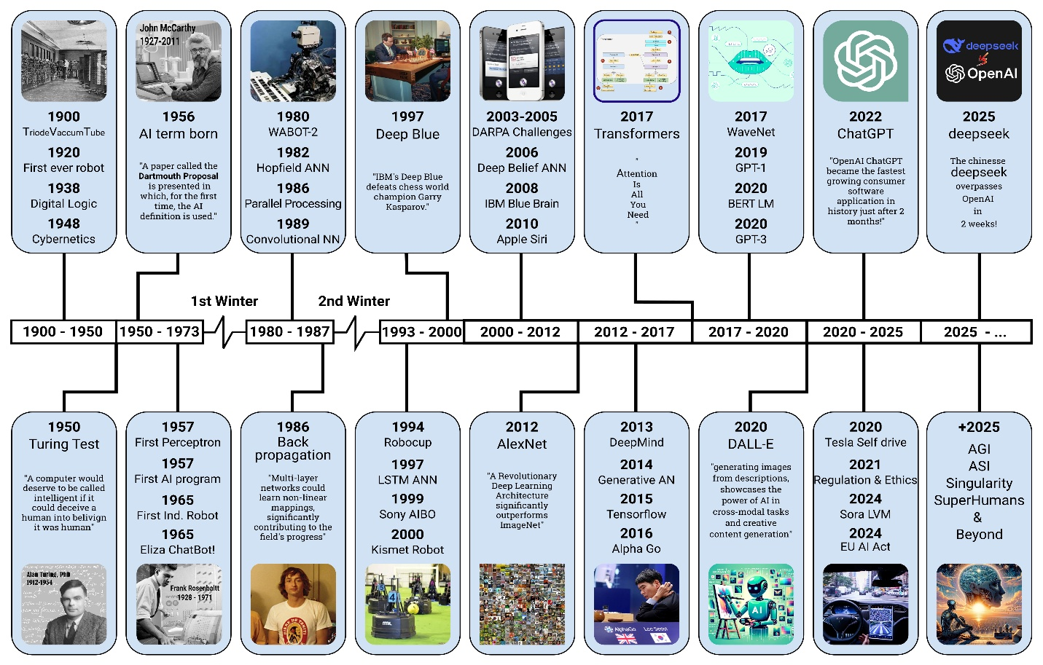
Researchers made little progress in the early years. Funding and interest dropped in the 70s and 80s. The period became known as the AI Winter. In the 90s computers got more powerful and could handle intensive calculations. In 1997 Deep Blue beat Garry Kasparov in chess. In 2011 IBM Watson won on Jeopardy. In 2016 AlphaGo beat Lee Sedol at Go. Since Go is more complex than chess, that win stood out as a major step forward ​(Moor, 2020)
Figure 2. Timeline of artificial intelligence developments from 1950 to projected future milestones.
Source: AI Timeline.png [Timeline]. Wikimedia Commons. (2025). https://commons.wikimedia.org/wiki/File:AI_Timeline.png

These systems were still limited. AlphaGo could play the game but couldn’t explain the rules in plain language. Suleyman (2023) said these tools weren’t intelligent in the human sense. They were good at specific tasks but had no real understanding beyond that. By the 2010s, deep learning, neural networks, and massive computing power brought AI back to the center of technological innovation. Suleyman describes this period as a shift away from symbolic rule-based systems and toward systems that learn from large datasets. This transition set the stage for the AI tools that now operate across nearly every industry.
AI has been shaped by theory and real breakthroughs. Early ideas led to machine learning and other tools we use today. Knowing that path helps explain why AI still raises hard questions about control, oversight, and its place in society.
Artificial intelligence has moved from theory to application. Over the last decade, technical advances in deep learning, data processing, and model design have changed how machines process language, recognize images, and make decisions. These systems are no longer limited to research labs. They now power tools in finance, health care, national security, and education.
AI refers to systems that simulate human intelligence by learning, reasoning, and generating outputs. These systems can identify objects, interpret language, make decisions, and operate independently (Stryker & Kavlakoglu, 2024). Most current systems are considered narrow AI, designed for specific tasks such as language generation, fraud detection, or vision processing (Stryker & Kavlakoglu, 2024).
Machine learning models are trained using labeled and unlabeled data. Supervised learning depends on labeled examples to classify inputs. Unsupervised learning finds structure in raw data. Semi-supervised learning combines both training on large datasets with limited labeled examples. Other types include reinforcement learning, which uses reward feedback, and transfer learning, where pretrained models adapt to new tasks (Stryker & Kavlakoglu, 2024; Dean, 2022, p. 67).
Neural networks are foundation of modern deep learning and are loosely inspired by the structure and function of the human brain. These models simulate neurons and synaptic connections in software, allowing data to be processed through layers that mimic biological pathways. While artificial neural networks are abstract and simplified, the connection to neuroscience remains important. In 2020, Google researchers used machine learning to help publish the Drosophila hemibrain connectome, the most detailed synapse-level map of a fruit fly brain ever created. This project used deep learning tools to segment and reconstruct neural tissue, enabling interactive 3D visualization of over 25,000 neurons and tens of millions of synapses (Dean, 2022, p. 63). This is a direct application of artificial intelligence to understanding biological intelligence. The convergence of neuroscience and AI not only strengthens the design of future models but also shows how tools originally modeled on the brain are now used to map real ones.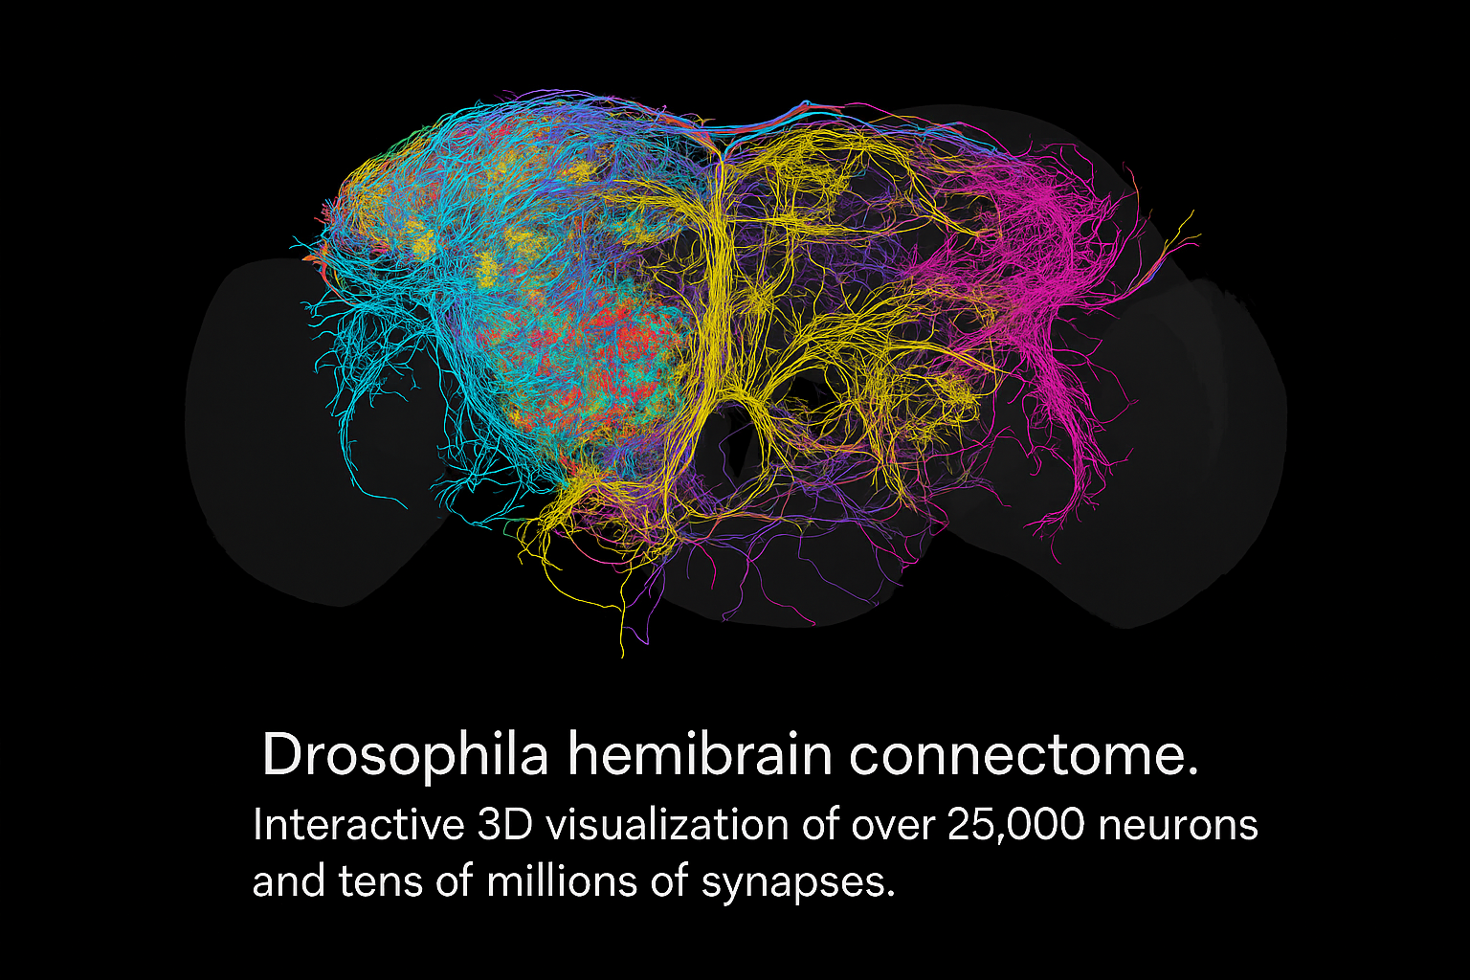
Figure 3. AI-generated illustration of the Drosophila hemibrain connectome. Source: AI-generated illustration of the Drosophila hemibrain connectome [AI-generated image]. ChatGPT (DALL·E). (2025). OpenAI. Used with permission under OpenAI’s content policy. https://openai.com/dall-e
The turning point came in 2012 when Geoffrey Hinton and his team used a deep convolutional neural network to win the ImageNet competition. Their model reduced the top 5 error rate and proved that neural networks could outperform traditional methods on large-scale image recognition tasks (Dean, 2022, p. 59). That same year, Andrew Ng and Jeff Dean at Google Brain showed that deep networks could identify faces and cats from millions of YouTube frames without any labels. They trained a model across 1,000 machines for three days, proving that scale could reveal useful representations (Dean, 2022, p. 60). Yann LeCun, who had developed convolutional networks for handwriting recognition, helped expand their use at Facebook AI Research to tasks in vision, video, and natural language (Dean, 2022, p. 60).
Even with these breakthroughs, pattern recognition remains difficult. A face recognition system may fail if a subject turns slightly or if lighting changes. "No two images of the same person are exactly the same," and variation in age, expression, or head position can distort results (Sirovich & Kirby, 1987, p. 519). Algorithms must tolerate these shifts by learning flexible feature descriptions rather than depending on static templates. Most systems still break under real-world variability (Sirovich & Kirby, 1987, p. 520).
Modern AI relies on transformer-based architecture, first introduced in 2017. These models process language by identifying patterns of attention across sequences. This design supports tasks like summarization, translation, classification, and question answering. They also apply to images, audio, and biological data such as protein sequences (Dean, 2022, pp. 66–67). Generative AI models, including transformers, diffusion models, and variational autoencoders, now produce original text, images, and video at scale. This capability is enabled by large-scale training, fine-tuning, and reinforcement learning with human feedback (Stryker & Kavlakoglu, 2024).
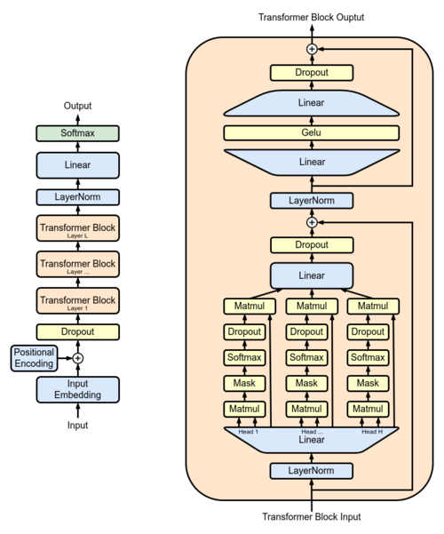
Figure 4. The diagram of a transformer architecture showing multi-head attention, self-attention layers, and normalization. This structure supports tasks such as translation, summarization, and language generation. Source: Full GPT Architecture.png [Diagram]. Wikimedia Commons. (2022, December 27). https://commons.wikimedia.org/wiki/File:Full_GPT_architecture.png
Synthetic biology follows a similar logic. It applies engineering principles to biological design. Organisms are programmed with custom DNA to perform tasks like nutrient production or pollutant removal. “Synthetic biology aims to design and construct new biological parts, devices and systems, and to re-design existing, natural biological systems for useful purposes” (Cameron et al., 2012, p. 671). Like early AI, it faces technical barriers such as inconsistent component behavior and weak modeling tools. Context often changes how genetic parts behave, making results less predictable (Cameron et al., 2012, pp. 675–676). The NIH outlines use such as yeast producing fragrance oil or rice engineered to deliver vitamin A to combat blindness (National Human Genome Research Institute, n.d.).
To handle privacy and efficiency, engineers use federated learning. This approach trains models locally on user devices and aggregates updates without moving raw data. It improves data protection and reduces risk (Dean, 2022, p. 66). Sparsely activated models are another efficient solution. These systems route each task through a small number of expert modules. “Such an approach is about nine times more efficient for training, about 2.5 times more efficient for inference, and more accurate” (Dean, 2022, p. 67). These methods reduce costs while expanding the capacity of AI systems.
Foundation models are the result of these advances. They are large pretrained systems that support a range of tasks without retraining from scratch. Models like GPT-4 can generate summaries, solve problems, or create original content using patterns learned from billions of words. These systems are available through platforms like Google Vertex AI, where developers can build applications with minimal code (Dean, 2022, p. 69).
Some of these systems now exceed human performance in narrow tasks. “AlphaFold exceeds all human scientists in predicting a protein’s 3D structure from an amino acid sequence” (IBM, n.d.). Deep Blue, Watson, and AlphaGo each demonstrated that models could beat world champions in games of logic, strategy, or knowledge (Suleyman, 2023, pp. 44–46). These are not general intelligence systems. They cannot adapt outside their domains. But they mark a shift in capability.
Current research focuses on building models that can handle many tasks with very little data. These systems mix methods like transfer learning, neural architecture search, and sparse activation. The goal is to make AI that runs efficiently, can scale, and stays safe. As these systems grow, they need oversight. Fairness, privacy, and clarity must keep up with the tech itself. Without that balance, powerful tools can get out of control or cause harm.
Artificial intelligence is evolving faster than our ability to regulate it. Suleyman (2023) argues that once released, powerful technologies like generative AI cannot be contained. They spread across platforms, borders, and applications faster than governments or companies can respond. Deep learning systems can create content that is indistinguishable from reality, including deepfakes, cloned voices, and fabricated media. These tools have already been used to impersonate people and manipulate information in politics and finance. Suleyman warns that this erosion of truth is not hypothetical. It is already happening. AI-generated content that appears factual but is false, known as hallucinations, further damages public trust and undermines information systems (Suleyman, 2023).
The ethical issues are deeper than just misuse. Modern AI systems are fundamentally opaque. Blais and Jungdahl (2019) explain that deep learning models operate as black boxes. They produce outputs without offering insight into how or why those outputs were generated. In national security and intelligence work, this lack of transparency is dangerous. These systems may detect patterns but miss intent, context, or strategy. When decision-makers rely on opaque tools without fully understanding their limitations, it creates serious risks. Errors, misjudgments, or biased outputs cannot be challenged or traced back to logic, making accountability nearly impossible.
IBM’s AI ethics guidance confirms that these problems are not theoretical. Bias, fairness, and explainability are real-world issues with serious consequences. IBM (2024) emphasizes that AI systems trained on skewed datasets can perpetuate discrimination, whether in hiring, lending, or healthcare. They advocate for models that are interpretable and auditable, especially in regulated industries. Explainability is not a luxury. It is the only way to build trust. IBM also outlines lifecycle governance practices including data documentation, auditing, and stakeholder input. They stress the importance of privacy protection, noting that AI systems can unintentionally leak sensitive data through logs, prompts, or flawed design.
Philosophical and societal concerns mirror these technical risks. The Stanford Encyclopedia of Philosophy explains that algorithmic decisions impact human rights, fairness, and personal autonomy (Moor, 2020). When people are evaluated, categorized, or denied services by AI systems they do not understand and cannot appeal, it diminishes their agency. Fairness in AI is not just about outcomes but about who controls the process. Relying on black-box logic, even when it is efficient, removes transparency from systems that directly affect human lives. Without ethical boundaries and proper oversight, AI shifts power away from individuals and communities toward invisible systems no one can challenge.
Artificial intelligence has introduced a set of legal and ethical problems that current laws were not designed to handle. Traditional legal frameworks rely on human intent or negligence, which does not apply to machine-generated outcomes. Harvard Law Review (2022) explains that autonomous systems like self-driving cars or AI decision tools complicate liability. When AI systems make mistakes, it becomes difficult to assign responsibility. Hiring platforms and credit scoring systems may produce biased outcomes, but legal challenges fail because it is unclear who or what is at fault. Cross-border inconsistencies in AI regulation make these problems worse. Without clear standards, accountability becomes uneven and fragmented across jurisdictions.
Privacy is still a major concern. IBM (2024) explains that AI systems can leak sensitive information through training data, prompts, or logs. They recommend limiting how much data is collected and making sure users give consent up front. Privacy must be part of the system from the start, not something added later. Strong oversight matters across the whole lifecycle. IBM calls for clear steps like tracking datasets, involving stakeholders, and doing regular audits to lower risk and stay transparent. They also support rules for accountability, especially in high-risk areas like finance and healthcare (IBM, 2024).

Figure 5. Conceptual illustration of artificial intelligence privacy, oversight, and data protection.
Source: AI Privacy and Oversight [AI-generated image]. ChatGPT (DALL·E). (2025). OpenAI. Used with permission under OpenAI’s content policy. https://openai.com/dall-e

AI's opacity challenges personal autonomy and ethical design. Moor (2020) argues that AI often makes decisions in areas like hiring or policing without the user’s knowledge or understanding. This undermines human agency. Systems that cannot explain their logic erode public trust. The lack of interpretability makes it harder to trace errors or correct harmful outputs. Black box models create a governance problem. Ethical AI design must include human oversight, transparency, and the ability to challenge machine decisions.
Intellectual property is still a gray area. The World Intellectual Property Organization (2023) says most copyright laws only protect work made by humans, so AI-generated content often has no clear owner. Some countries are trying out laws that give rights to the developer, while others don’t allow protection at all. There are also open questions about training data. Using copyrighted material to train AI might break the law, depending on where it happens and how fair use is defined. There’s no global rule, so the legal picture is still unclear for both developers and creators.
The policy and regulatory environment surrounding AI is not keeping pace. Suleyman (2023) argues that once powerful systems are deployed, they cannot be recalled or reliably contained. They spread faster than institutions can adapt. Industry often downplays risks while regulators respond too slowly. This results in a governance vacuum. Without proactive oversight, containment becomes nearly impossible. Suleyman warns that transparency, control, and enforcement must be designed before harm occurs, not after.
Environmental regulation is part of this challenge. According to de Vries-Gao (2025), AI already accounts for up to 20 percent of global data center electricity use, and that number may reach 50 percent by year end. Google’s emissions have increased by 48 percent since 2019. Yet few policies exist to track or reduce this environmental cost. The Olympic College seminar “AI and Me” confirmed this impact at the local level. Projects like Sassy and Firecracker in Washington State have caused air and water pollution, redirected hydroelectric energy, and increased cancer risk in nearby communities. These projects also push up local energy costs and increase the frequency of power outages. Cobalt mining and short device life cycles further intensify global environmental and human rights damage. Without new rules on emissions, energy transparency, and ethical sourcing, AI will continue to strain ecosystems and public infrastructure.
Stronger policy is needed to manage these risks. IBM (2024) supports mandatory audit frameworks, data transparency, and ethical lifecycle governance. Suleyman (2023) calls for systemic containment architecture that includes enforcement, education, and global cooperation. Public institutions must align AI development with democratic oversight and environmental sustainability. The longer the regulation is delayed, the more damage becomes irreversible.
Policy is the structural counterpart to governance. Without policy, ethical guidelines and technical safeguards have no enforcement. Suleyman (2023) argues that AI is uncontainable once released. These systems diffuse across borders, industries, and platforms faster than governments can respond. They are dual use by default. The same model can improve medical diagnostics or power disinformation campaigns. For that reason, containment must be built into AI systems before deployment or it becomes impossible to regain control (Suleyman, 2023, p. 13).
Suleyman also warns that current institutions are too slow to react. Bureaucracy, inertia, and political fragmentation allow industry to dominate the pace of development. The result is a governance vacuum where no one has the authority or structure to enforce safety or fairness (Suleyman, 2023, pp. 13–14). To fill that gap, policy must encourage shared control. No single group—academic, government, or private sector—can manage the risks alone. Coordinated frameworks must align goals and distribute responsibility (Suleyman, 2023, p. 14).
IBM (2024) supports this view with specific recommendations. They outline policy-level standards for lifecycle governance, requiring AI models to be documented, monitored, and reviewed from design through deployment. IBM calls for auditability, where models must be traceable and explainable, especially in high-risk domains. They reject the use of black-box systems in decisions that affect people’s rights or access to services. Regulation should classify systems based on risk and apply strict oversight to those that pose the greatest potential harm (IBM, 2024).
Policy must also address labor disruption and civic education. AI systems are already replacing workers in logistics, analysis, and customer service. Suleyman (2023) describes the effect not as job loss but as structural change. Governments need to develop long-term strategies for retraining, employment policy, and public communication about automation (Suleyman, 2023, p. 14). Without AI literacy, democracy itself is threatened. If only a few people understand how AI works, then only a few people can influence how it is used. Suleyman urges policymakers to expand access to AI education and ensure that the public can participate in shaping its future (Suleyman, 2023, p. 14).
Artificial intelligence has moved from theory to infrastructure in less than a century. What began as a question of whether machines could think is now a question of how we will live with systems that are already shaping critical decisions across healthcare, finance, education, and national defense (Suleyman, 2023). This paper has shown how AI evolved from early research in logic and games to large-scale systems that can generate language, images, and decisions (Moor, 2020; Dean, 2022). It has also examined the risks that come with that evolution.
Ethical concerns such as bias, transparency, and surveillance are not hypothetical. They are already present in the tools being deployed today (IBM, 2024). Legal frameworks are outdated, and accountability often fails when AI systems make mistakes that affect real people (Harvard Law Review, 2022). Privacy and intellectual property protections are under pressure as models expand in scale and reach (World Intellectual Property Organization, 2023). Regulation has not kept up with development, and many governments remain unprepared to manage AI’s impact (Suleyman, 2023). Meanwhile, environmental costs continue to grow as data centers consume more energy and water to support increasingly powerful models (de Vries-Gao, 2025; Olympic College, 2025).
Policy responses must match the speed and scale of AI development. This includes containment strategies, governance across sectors, and education that empowers the public to understand and question these systems (Suleyman, 2023; IBM, 2024). AI is not neutral. Its future will depend on decisions made now by engineers, lawmakers, educators, and communities. Without action, the risks of misuse, inequality, and ecological damage will grow. With the right approach, AI can remain a tool, not a force that outpaces our ability to control it.

References
Suleyman, M., & Bhaskar, M. (2023). The Coming Wave: Technology, Power, and the Twenty-first Century’s Greatest Dilemma. Crown Publishing.
Dean, J. (2022). A golden decade of deep learning. Dædalus, 151(2), 55–71.
Moor, J. H. (2020). The history of artificial intelligence. In E. N. Zalta (Ed.), *The Stanford Encyclopedia of Philosophy* (Fall 2020 Edition). Stanford University. https://plato.stanford.edu/entries/artificial-intelligence/
IBM. (2024). What is artificial intelligence? https://www.ibm.com/topics/artificial-intelligence
Harvard Law Review. (2022). AI and legal liability: The future of responsibility in autonomous systems. Harvard Law Review, 135(4), 1234–1278.
World Intellectual Property Organization. (2023). Copyright law and artificial intelligence. https://www.wipo.int/wipo_magazine/en/2023/01/article_0002.html
Stryker, C., & Kavlakoglu, E. (2024, August 9). What is artificial intelligence (AI)? IBM. https://www.ibm.com/think/topics/artificial-intelligence
Cameron, D. E., Bashor, C. J., & Collins, J. J. (2012). A brief history of synthetic biology. Nature Reviews Microbiology, 10(5), 379–386.
de Vries-Gao, A. (2025, May 22). AI is eating data center power demand—and it's only getting worse. Joule. https://www.wired.com/story/new-research-energy-electricity-artificial-intelligence-ai/
Olympic College. (2025, April). AI and Me: Environmental Impact of AI. Seminar attended at Olympic College, Bremerton, WA.
Glymour, C. (1992). Thinking things through: An introduction to philosophical issues and achievements. MIT Press.
Halpern, J. Y., et al. (2001). Reasoning about uncertainty. MIT Press.
Sirovich, L., & Kirby, M. (1987). Low-dimensional procedure for the characterization of human faces. Journal of the Optical Society of America A, 4(3), 519–524.
Blais, J. R., & Jungdahl, A. M. (2019). Artificial intelligence in a human intelligence world. American Intelligence Journal, 36(1), 60–65.
Adobe Stock. (n.d.). Alan Turing [Stock photo]. https://stock.adobe.com
Wikimedia Commons. (2025). Timeline of AI developments. https://commons.wikimedia.org
ChatGPT (DALL·E). (2025). AI-generated illustration of the Drosophila hemibrain connectome [AI-generated image]. OpenAI. Free for academic and commercial use.

Appendix A
Additional Research Sources
The following sources were reviewed during the research process but were not directly cited in the main text.
Brundage, M., Avin, S., Clark, J., Toner, H., Eckersley, P., Garfinkel, B., ... & Amodei, D. (2018). The malicious use of artificial intelligence: Forecasting, prevention, and mitigation. Future of Humanity Institute, University of Oxford. https://arxiv.org/abs/1802.07228
Brynjolfsson, E., & McElheran, K. (2023). Generative AI at work (NBER Working Paper No. 31161). National Bureau of Economic Research. https://www.nber.org/papers/w31161
Deloitte. (2023a). The implications of generative AI for businesses. https://www2.deloitte.com/us/en/pages/consulting/articles/generative-artificial-intelligence.html
Deloitte. (2023b). Proactive risk management in generative AI. https://www2.deloitte.com/us/en/pages/consulting/articles/responsible-use-of-generative-ai.html
Google AI Blog. (2023). Introducing Gemini, LaMDA, and efficient prompt tuning. https://ai.googleblog.com/
McKinsey & Company. (2023). What is generative AI? https://www.mckinsey.com/featured-insights/mckinsey-explainers/what-is-generative-ai
MIT Technology Review. (2023, April 27). The future of generative AI is niche, not generalized. https://www.technologyreview.com/2023/04/27/1072102/the-future-of-generative-ai-is-niche-not-generalized/
Oakleaf, M., et al. (2014). The information literacy user's guide: An open, online textbook. Open SUNY Textbooks.
Roose, K. (2022, October 21). Generative AI is here. Who should control it? The New York Times. https://www.nytimes.com/2022/10/21/podcasts/hard-fork-generative-artificial-intelligence.html
Salamone, L. (2023). What is temperature in NLP? https://lukesalamone.github.io/posts/what-is-temperature/
Stanford HAI. (2023). Generative AI: Perspectives from Stanford HAI. https://hai.stanford.edu/sites/default/files/2023-03/Generative_AI_HAI_Perspectives.pdf
Su, J. (2023, November 14). Google's AI course for beginners (in 10 minutes)! [Video]. YouTube. https://www.youtube.com/watch?v=Yq0QkCxoTHM
Tegmark, M. (2017). Life 3.0: Being human in the age of artificial intelligence. Penguin Books.
The Gradient. (2021). NLP's ImageNet moment has arrived. https://thegradient.pub/nlp-imagenet/
Wikipedia contributors. (2023, December 10). Transformer (machine learning model). Wikipedia. https://en.wikipedia.org/wiki/Transformer_(machine_learning_model)
Worley, B. (2024). Review of The coming wave: Technology, power, and the 21st century's greatest dilemma by M. Suleyman & M. Bhaskar. Æther: A Journal of Strategic Airpower & Spacepower, 3(3), 96–98. https://www.jstor.org/stable/48793187

